Explain the basic components of a computer (input device, output device, central processing unit, and memory) briefly, as illustrated in the figure below. Write about 150 words.

简单解释一下计算机的基本组成部分(输入设备、输出设备、中央处理器和内存)，如下图所示。写150字左右。

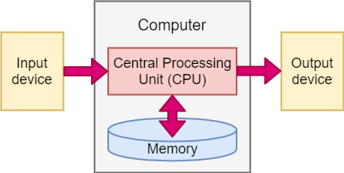

Input device is a device used for human-computer interaction, to input raw data and the programs that process these data into the computer. Computer can receive a wide variety of data, both numerical and nun-numerical data. Such as graphics, images, sound, etc. can be input to the computer through different types of input devices. Output device is a terminal device of computer hardware system, which is used to display various result data and information in the form of numbers, characters, images, sound, etc.

Central Processing Unit is the core accessories of the computer. Its function is mainly to explain computer instructions and processing data in computer software. The CPU is the core unit that controls and allocates all hardware resources of the computer. All operations in the software layer of a computer system are eventually mapped to CPU operations through the instruction set. Memory is a memory device used to store information. All information in the computer is saved in the Memory, which stores and takes out information according to the position specified by the controller.

The overall process is that data is input to the computer from outside of the computer via input devices, and after the CPU processing and the memory storage and acquisition, the output device will output the result.